(Japanese Version)
(Arabic Version)

(contents)

The Peace on The Horizon - 75 Years after The World War 2 in the Middle East (31)

Chapter 1. Wave of nationalism and socialism (1945-1956) (15)

031. Israeli independence(4): Independence of Israel after terrorism against UK(1/3)
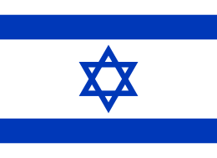
Terrorism means the use of intentionally indiscriminate violence as a means to create terror, or fear, to achieve a political, religious or ideological aim. Terror accompanied with civilian victim is never permitted. Terror usually occurs in the battle of the nation's independence. The ruler or authority of the time sees terror as a criminal act disturbing social order. The anti-governmental power, on the contrary, argues that terrorism is one of the legitimate measures for achieving the object. There is no compromise between the two assertions.

Many terrorist acts are usually crushed by authorities who hold security power, but when the rebellion takes power and the independence is recognized as a new state, the position will be reversed. The terror acts of the rebels presume as patriotic acts. The performers of terrorism will be admired as hero/heroine, and international community will accept new regime. After the World War II the nation state was the basic unit. Political scientists pretend that only the state is allowed to have legitimate violence unit.

(To be continued ----)

Areha Kazuya
(From an ordinary citizen in the cloud)

